`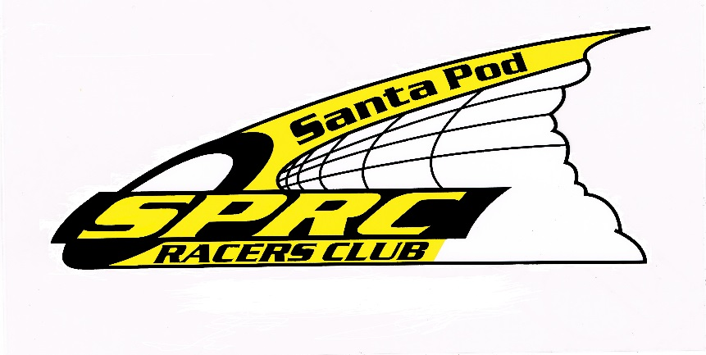
Santa Pod Racers Club
P O Box 12
Rushden
Northants NN10 0ZU
Tel: (0044) 01933 313625
Fax: (0044) 01933 355558
E-mail: ir.marshall@btconnect.com

SUPPLEMENTARY REGULATIONS

BIG BANG - DRAG RACE AT SANTA POD RACEWAY

23-24 APRIL 2016

Status of Event: NATIONAL B

Championship: 2016 VWDRC CHAMPIONSHIP
2016 NATIONAL CHAMPIONSHIP
2016 SPRC SPORTSMAN CHAMPIONSHIP
2016 JDS DRAG SERIES
2016 FWD Drag Series
2016 NOSTALGIA FUEL FUNNY CAR CHAMPIONSHIP

These Supplementary Regulations are in addition to the 2016 MSA Competitors Yearbook (Bluebook) and the 2016 MSA Official Drag Racing Rulebook.

Held under the General Regulations of the Motor Sports Association Ltd (incorporating the provisions of the International Sporting Code of the FIA) and the Supplementary Regulations.

Organised by: Santa Pod Racers Club MSA Permit No: 92726
MSA Steward: TBA
P O Box 12 MSA Scrutineer: TBA Rushden Secretary of the Meeting: Mrs Y Tramm
Northants Clerk of the Course: Mr I Marshall
NN10 0ZU Asst. Clerk of the Course: Mrs C Ismail
Chief Timekeeper: Mr D Anniwell
Club Stewards: Mr S Tramm &
Mr S McDonald

Promoted by: Santa Pod Raceway
Airfield Road
Hinwick
Northants
NN29 7XA

National B event is open to all UK racers who are members of SPRC or APIRA, holding a minimum of MSA National B Licence (excluding Karts) and foreign competitors holding EC Licences (minimum National grade) bearing the EC flag and endorsed with “Valid throughout the EC” running in Junior Dragster, VW Sportsman, VW Pro, Outlaw Anglia, Sportsman ET, FWD Drag Series, JDS Pro, JDS Street, Outlaw Flat Four, Jet Car.

SPRC & APIRA CLUB MEMBERSHIP CARDS WILL BE INSPECTED AT SIGNING ON.

The event will be held as a drag race over a 1/4 or 1/8 mile length course and is open to all eligible race cars for the following classes:

Nostalgia Fuel Funny Car, Junior Dragster, VW Sportsman, VW Pro, Outlaw Anglia, Sportsman ET,FWD Drag Series, JDS Pro, JDS Street, Outlaw Flat Four, Jet Car.

Entry to the event opens January 2016 and closes Friday, 1st April 2016 with an entry fee of £130.00 & £155.00 made payable to SPRC and sent to SPRC, P O Box 12, Rushden, Northants, NN10 0ZU. In addition an Electricity fee of £45 for providing single phase 240 volt, 13 amps will be charged to all competitors. There will be no 3 phase electric at this event.

Maximum number of entries will be 250 with a minimum of 30.

Scrutineering will start at 7 am Saturday morning until eliminations begin.

All cars must have race numbers visibly displayed to include prefix of class and number as issued by the organising club.

All competitors must have a fire extinguisher within their pit area to conform to Health & Safety requirements. This is in addition to any fire extinguisher systems within race vehicles.

All cars will start in pairs where possible, start signal indicated by green light.

The posted prize fund for this event is trophies.

The Club reserves the right to refuse any entry without reason and abandon, cancel or postpone the meeting or alter the programme of events and awards.

Judges of Fact for the event are MSA Scrutineer – TBA, Mr S Johnson, Mr R Bell, Mr S Warner, Mr D Anniwell & Mr D Warren who will judge any track/race violations.

Results for the events will be available 1 hour after the close of the event.

Protests: Reference should be made to the 2016 MSA Year Book Section “O”.

Racers will pit as per final instructions.

The racing will start at 3 pm Saturday 23rd April and 9.30 am Sunday 24th April track conditions permitting.

Winner is determined by the first over the finish line in heads up classes or first over the finish line without breaking out of their dialled in time if a handicapped race.

For further rules and regulations please see the 2016 MSA Competitors Yearbook (Bluebook) and the 2016 MSA Official Drag Racing Rulebook.

Whilst every effort will be made to provide sufficient turnaround time, racers entering across 2 or more classes, please note that it is your responsibility to be in the fire up road in time for each round of both qualifying and eliminations, the Race Director will not be held responsible for changes to the event programme and thus racer turnaround time. Racers double enter accepting all responsibility for being in the right place at the right time.

OFFICIAL EVENT ENTRY FEE £130

ENTRY FORM Single Phase Electric £45

CLOSING DATE FOR ENTRIES AT NORMAL FEE: 2 APRIL 2016

EVENT: BIG BANG: 23-24 APRIL 2016 VENUE: SANTA POD RACEWAY
PROMOTED BY: SANTA POD RACEWAY ORGANISED BY: SANTA POD RACERS CLUB

Drivers Name......................................................... Address...........................................……………………………………

Post Code...............................................................Tel...................................................... ………………..........................

Entrants Name........................................................Address………………………………..................................................

Post Code...............................................................Tel……………………………..............................................................

Make of Car..................................................Model..........................................Name.......................................................

Engine Size........................................Race No………………………………..Tech Inspection Number…….....................

In case of emergency contact: Mr/Mrs/Miss....................................................................................................................

Address........................................................................ Post Code............................. Tel..............................................

CLASS YOU WISH TO ENTER –
VW Pro |  | VW Sportsman
Outlaw Anglia |  | Sportsman ET
FWD Drag Series |  | Outlaw Flat Four
JDS Street |  | JDS Pro

The correct entry fee & electricity fee, this form and a stamped addressed envelope should be returned no later than 1st April 2016 to:-
S.P.R.C. PO BOX 12, RUSHDEN, NORTHANTS, NN10 0ZU.
I agree to abide by the 2016 MSA Official Drag Racing Rulebook, MSA rules and any subsequent regulations officially promulgated.

SIGNED......................................................................................................................DATE...........................................
PLEASE ALSO SIGN THE DECLARATION ON THE SECOND PART OF THIS FORM

I enclose cheque/postal order in the sum of £175 (inc elec) made payable to SPRC
In order to pay by BACS please complete the amount * and add your surname and race number as the payment reference
(Max 16 characters please)

I enclose cheque/postal order in the sum of £305 for late entry (after 1/4/2016) made payable to SPRC
`

Payment of £……………* has been sent by BACS to the SPRC Account No 90798290 Sort Code 20-45-77

I wish to pay by Mastercard/Eurocard/Visa/Delta/Switch/Barclay Connect
A SURCHARGE OF 4% WILL BE MADE FOR CREDIT/DEBIT CARD PAYMENTS
I authorise you to debit my card number with the amount of £175 PLUS £7.00 surcharge

I wish to pay by Mastercard/Eurocard/Visa/Delta/Switch/Barclay Connect
A SURCHARGE OF 4% WILL BE MADE FOR CREDIT/DEBIT CARD PAYMENTS
I authorise you to debit my card number with the amount of £305 PLUS £12.20 surcharge, for late entry

Card Number Expiry Date

Signature of Card Holder ………………………………………………… Last 3 digits on reverse of card __________________

If paying by Switch card, please advise Issue No: ___ and/or Valid from and Valid to dates: ______________________________

Name of Card Holder........................................................................................................................................................
Address..........................................................................................................................Post Code..................................

FOR OFFICIAL USE
No of Tickets left on gate...............................No of Tickets sent..............................Entry Fee Received........................

* TO BE SIGNED BY ALL DRIVERS/ENTRANTS *

INDEMNIFICATION

DECLARATION ‘A’ - Driver/Entrant
I have read the supplementary regulations issued for this event and agree to be bound by them and the general regulations of the MSA Ltd, and the general competition rules of the ACU and the Code of the FIM. In consideration of the acceptance of this entry or of my being permitted to take part in this event, I agree to save harmless and keep indemnified the Motor Sports Association Ltd., the South Midlands Centre ACU and the FIM and such person, persons or body as may be authorised by the Motor Sports Association Ltd or ACU to promote or organise this event and their respective officials, servants, representatives and agents from and against all actions, claims, costs, expenses and demands in respect of death or injury to myself, howsoever caused, arising out of or in connection with this entry or my taking part in this event and notwithstanding that the same may have contributed to or occasioned by the negligence of the said bodies, their officials, servants, representatives or agents. Furthermore in respect of any parts of this event on ground where third party insurance is not required by law this agreement shall in addition to the parties named above extend to all and any other competitor(s) and their servants and agents and to all actions, claims, costs, expenses and demands in respect of loss or damage to the person or property of myself, my driver(s) or mechanic(s).

DECLARATION ‘B’ - Driver Only (in addition to ‘A’ above)
I understand that should I, at the time of this event, be suffering from any disability, whether permanent or temporary, which is likely to affect prejudicially my normal control of my vehicle, I may not take part unless I have declared such disability to the Motor Sports Association Ltd, or ACU who have, following such declaration, issued a licence which permits me to do so.

DECLARATION ‘C’ - Entrants Only (in addition to ‘A’ above)
I declare that, to the best of my belief, the driver possesses the standard of competence necessary for an event of the type to which this entry relates and that the vehicle entered is suitable and roadworthy for the event, having regard to the course and the speeds which will be attained.

“I declare that I am over 16 years of age”.

If a driver, passenger or entrant is under 18 years of age, this declaration must also be signed by a parent or guardian.

SIGNED ............................................................... * Driver / Entrant
* Delete as applicable

Name........................................................................ Race No.................................

SIGNED……………………………………………………*PARENT / GUARDIAN

